WEEK 8 – STUDENT PERFORMANCE DASHBOARD

1. Objective
The objective of this project is to create an interactive Student Performance Dashboard using Microsoft Power BI. The dashboard analyzes students' academic scores and compares performance based on subject, parental education, test preparation, and lunch type.

2. Dataset
The dataset used is StudentsPerformance.csv. It contains 1,000 student records with demographic details, educational background, test preparation information, and Mathematics, Reading, and Writing scores.

3. KPI Cards
Three KPI cards are used to display the average scores of students in different subjects.
- Average Math Score: Displays the average Mathematics score.
- Average Reading Score: Displays the average Reading score.
- Average Writing Score: Displays the average Writing score.
These cards provide a quick overview of students' academic performance.
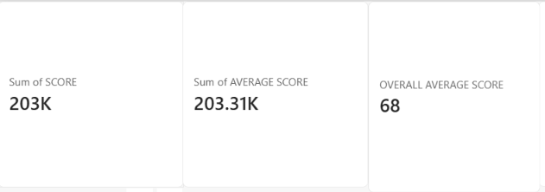

4. Data Visualization

4.1 Average Score by Parental Education
A column chart compares students' average scores across different parental education levels. It helps identify performance differences among the groups.
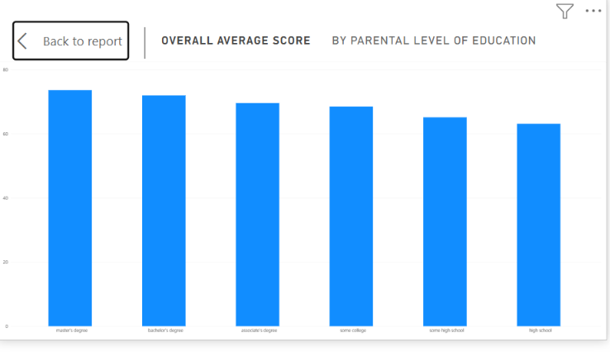

4.2 Average Score by Test Preparation
A chart compares student performance based on whether students completed the test preparation course. It helps examine differences in average scores between the groups.
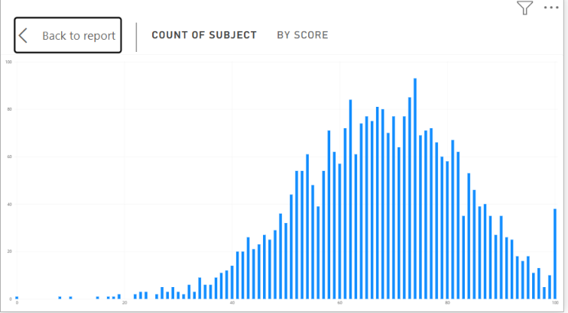

4.3 Average Score by Lunch Type
A chart compares academic scores according to lunch type. It helps analyze differences between students receiving standard lunch and free/reduced lunch.
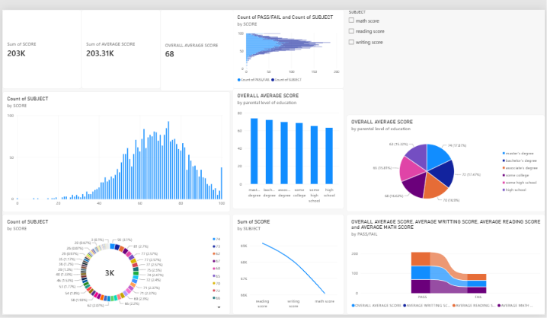

4.4 Performance Grade Distribution
A doughnut chart displays the distribution of students across different performance grades. It provides a visual summary of students' academic performance.
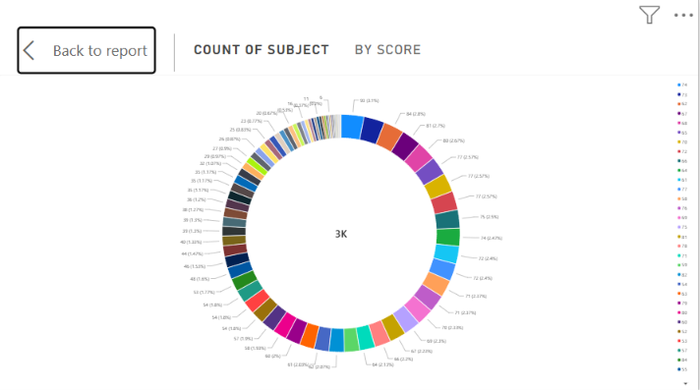

4.5 Average Score by Subject
A chart compares the average scores in Mathematics, Reading, and Writing. It helps identify differences in performance across the three subjects.
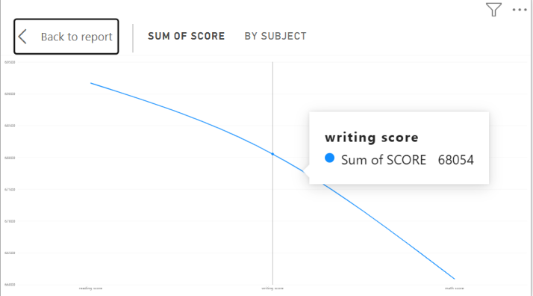

4.6 Pass/Fail Distribution
A chart displays the distribution of students classified as Pass or Fail. It provides an overview of the students' performance classification.
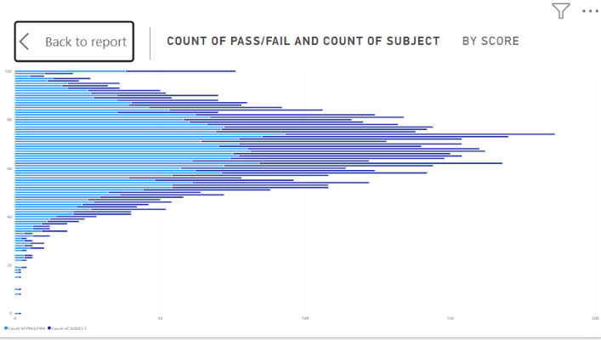

5. Interactive Slicers
Slicers are used to filter the dashboard based on selected categories.
- Gender
- Race/Ethnicity
- Lunch Type
- Test Preparation Course
These slicers allow users to explore and compare student performance across different groups.
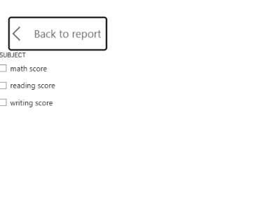

6. Dashboard Design
The dashboard is arranged using KPI cards, charts, and slicers. Appropriate chart types and titles are used to make the information easier to understand. The visual layout helps users compare academic scores and explore performance patterns.
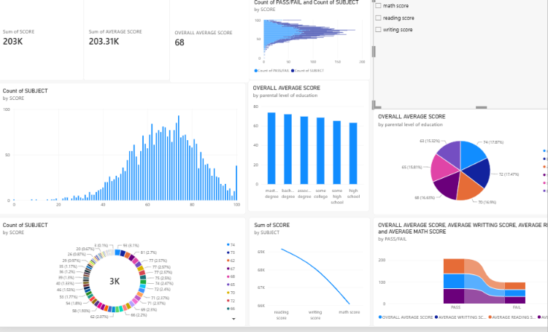

7. Key Insights
The dashboard helps identify:
- Differences in average scores across Mathematics, Reading, and Writing.
- Performance differences among parental education groups.
- Differences between students who completed test preparation and those who did not.
- Academic score differences based on lunch type.
- The distribution of students across performance grades and Pass/Fail categories.
The actual findings can be recorded after reviewing the values displayed in the dashboard.

8. Validation
The dashboard visuals and KPI cards are checked to ensure that the correct measures and fields are used. The slicers are also checked to confirm that they filter the report correctly.

9. Outcome
The Student Performance Dashboard presents student score information through KPI cards, charts, and interactive filters. It makes it easier to compare academic performance and explore differences among student groups.

10. Conclusion
The Week 8 project demonstrates how Microsoft Power BI can be used to create an interactive dashboard for student performance analysis. The dashboard presents important academic information in a clear visual format and supports data-driven comparisons.

